**My experience with personality tests:**

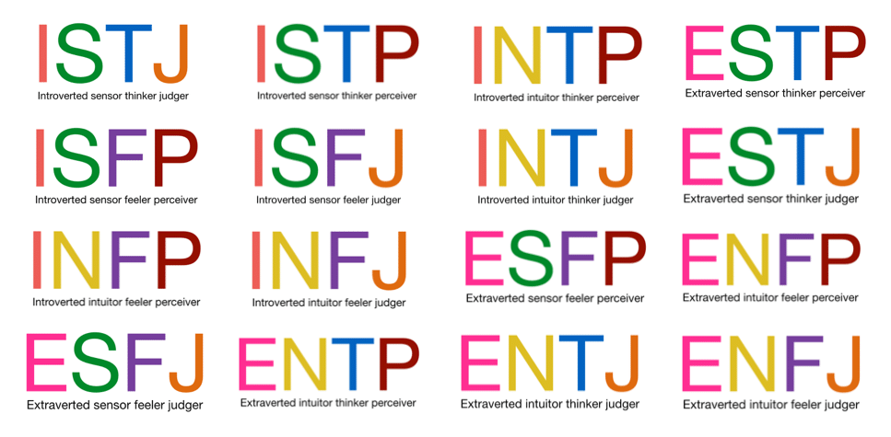Many people believe that the origin of personality is a combination of the environment an individual was raised in as well as the experiences they have growing up. Many small individual experiences can change an individual’s personality from when they are a child to when they mature into adulthood. Over the course of my life I’ve been involved with many leadership organizations that have asked me to take various different personality tests such as the ***Strengthsfinder, Myers Briggs, Winslow Personality Profile,*** and the ***Personality Assessment System***. Each of these tests were given to me at various points throughout my life from ages 10-19, now taking this test is interesting to see how my personality has developed over the course of my life.

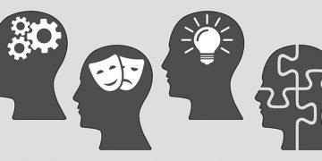**Comparing my old results to now:**

When I first took a personality test, all my results came up as an introvert, and as very analytical. I was very aware at the time that I wasn’t very outgoing and that I wasn’t the most creative kid in my class. At the time, I was very upset at my results, I felt that being an introvert was something to be embarrassed about, I thought that because I was shown to be an introvert, it meant that I wasn’t a very likeable person, and I wouldn’t develop the social skills necessary to succeed in life. This was a pivotal moment in my life, I decided from that point on I would develop as many social skills as possible as well as read leadership books to instill some kind of extrovert qualities. It was when I was 16 that I took another personality quiz that came up slightly different. About 3/4 of my results represented that of an extrovert, but I was also depicted as a more analytical thinker than a creative thinker. It 2 months after, in my entrepreneurship class that I realized that being an introvert or an analytical person wasn’t actually a bad thing if I embraced all of my good qualities and learned from my bad ones. In the past year, I’ve taken 3 different personality tests including this most recent one, and my results are about half and half. I’m still very much analytical, but I test about 60% extroverted, and 40% introverted.

**Analyzing my most recent results:**

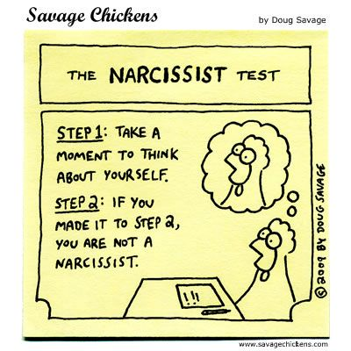 This time my results were for the most part similar to the personality tests I’ve taken in the past year my results came back as an extrovert, highly idealistic and analytical. There were however a few new tests that I have never taken, such as the work-involvement test as well as the “Am I a narcissist” test. My results showed that I am a 41/60 as far as the involvement scale and a 5/12 on the Am I a narcissist scale. As far as insights from these tests, I can use these results to see how far I have come since my first personality assessment, as well as see what distinguishable traits I am developing as I age. The Jungian test did give me some possible career paths such as an architect, journalist, or an actor, but as far as careers go, I’ve learned that personality tests don’t necessarily have the best predictors for me. My first test told me that I should be a doctor, and shortly after I received a D+ on my first biology exam, my following personality tests told me that I should be a lawyer, until I realized I abhorred writing papers longer than 5 pages. However, the job pathways are a nice tool to utilize to see what aspects of that certain job they are recommending appeal most to my personality type, such as hands-on work, working with people, or leading teams of employees.